PGDM (ABM) 2016-18 Batch
Congratulations to

Mr. Venkata Raghava Vittal Tadikonda

Graduated from Annamalai University, Chidambaram, Tamil Nadu.
Post-Graduation from Food and Agri Business School, Hyderabad, Telangana

Mr. Gundapu Panchajanya Kumar

Graduated from Annamalai University, Chidambaram, Tamil Nadu.
Post-Graduation from Food and Agri Business School, Hyderabad, Telangana

Mr. Pawar Sai Shiva Shankar

Graduated from College Of Agriculture, Udgir, Latur Maharashtra.
Post-Graduation from Food and Agri Business School, Hyderabad, Telangana
Got Placed in
National Collateral Management Services Limited (NCML)
As an Executive Trainee (Business & Operations)

PGDM (ABM) 2016-18 Batch
Congratulations to
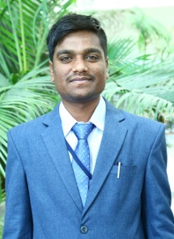

Mr. Sunil
Graduated from Vasantrao Naik Marathwada Krishi Vidyapeeth - [VNMKV], Parbhani, MH.
Post-Graduation from Food and Agri Business School, Hyderabad, Telangana

Got Placed in
Coromandel International Limited
as an Agronomist
……………………………………………………………………………………………………………………………….

PGDM (ABM) 2016-18 Batch
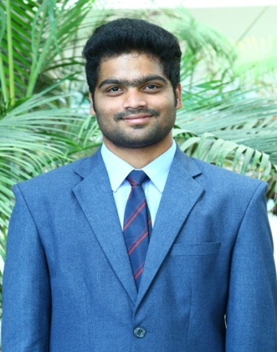
Congratulations to

Mr. Mekala Rohith Reddy

Graduated from Vasantrao Naik Marathwada Agricultural University, Parbhani, MH.
Post-Graduation from Food and Agri Business School, Hyderabad, Telangana
Got Placed in
eFresh Agri Business Solutions Private Ltd.
as a Management Trainee
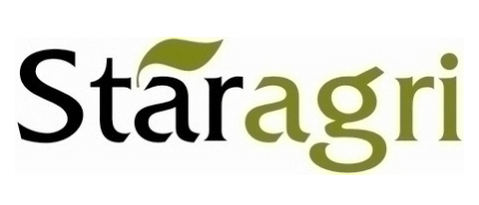

PGDM (ABM) 2016-18 Batch
Congratulations to
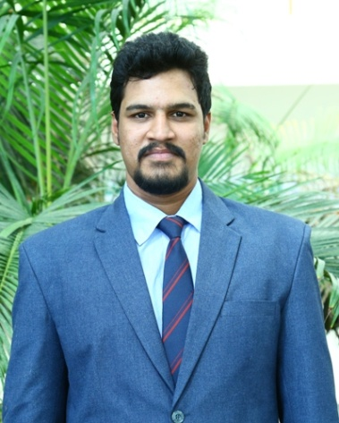

Mr. Sampathi Sainath
Graduated from College of Agriculture, Nanded Road, Udgir, Latur Maharashtra.
Post-Graduation from Food and Agri Business School, Hyderabad, Telangana

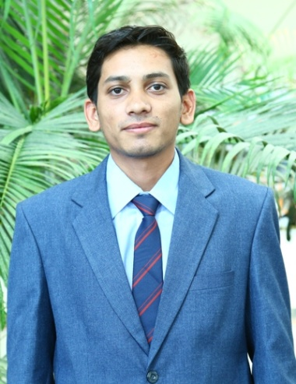

Mr. Ramkrishna Patel
Graduated from Swami Vivekanand University, Madhya Pradesh.
Post-Graduation from Food and Agri Business School, Hyderabad, Telangana

Got Placed in
Staragri Warehousing and Collateral Management Ltd.
as a Management Trainee

PGDM (ABM) 2016-18 Batch
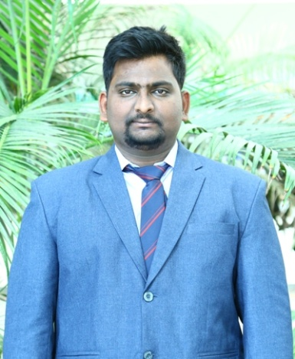
Congratulations to

Mr. A Rohith Kumar

Graduated from Vasantrao Naik Marathwada Agricultural University, Parbhani, MH.
Post-Graduation from Food and Agri Business School, Hyderabad, Telangana
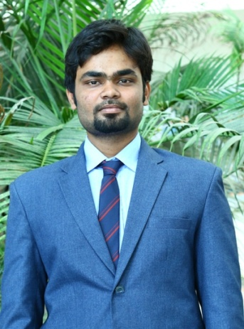

Mr. Kancharla Siva Sai Sagar Reddy

Graduated from Annamalai University, Chidambaram, Tamil Nadu.
Post-Graduation from Food and Agri Business School, Hyderabad, Telangana

Got Placed in
Poorti Agri Services Private Limited.
as a District Manager

PGDM (ABM) 2016-18 Batch
Congratulations to
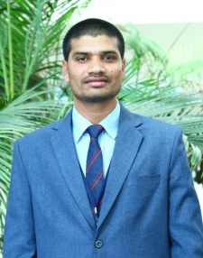

Mr. Manoj Kumar Rajput
Graduated from Institute of Agricultural Sciences, Bundelkhand University, Jhansi, UP.
Post-Graduation from Food and Agri Business School, Hyderabad, Telangana

Mr. Sirigireddy Mahendranath Reddy
Graduated from Annamalai University, Chidambaram, Tamil Nadu.
Post-Graduation from Food and Agri Business School, Hyderabad, Telangana

Got Placed in
Cocoon Logistics (Part of Cocoon-Group Ltd.)
as a Management Trainee

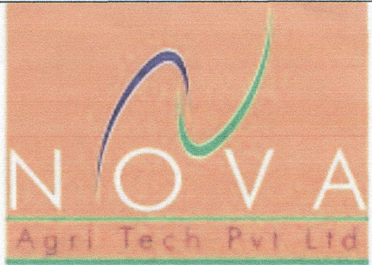
PGDM (ABM) 2016-18 Batch
Congratulations to
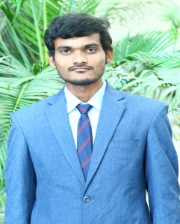

Mr. Kolli Srinivas Reddy

Graduated from Annamalai University, Chidambaram, Tamil Nadu.
Post-Graduation from Food and Agri Business School, Hyderabad, Telangana
Got Placed in

Nova Agritech Private Limited
as an Executive- Sales & Marketing
……………………………………………………………………………………………………………………………….

PGDM (ABM) 2016-18 Batch
Congratulations to

Mr. Papudippu Jitendra

Graduated from Annamalai University, Chidambaram, Tamil Nadu.
Post-Graduation from Food and Agri Business School, Hyderabad, Telangana
Got Placed in

AXIS Bank Limited
as a Agri Lending Manager

PGDM (ABM) 2016-18 Batch
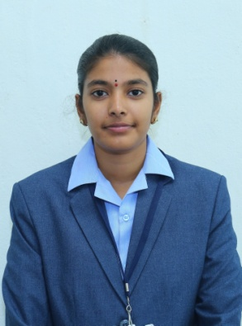
Congratulations to

Ms. Thamenidi Mrudhula Chowdhary
Graduated from Annamalai University, Chidambaram, Tamil Nadu.
Post-Graduation from Food and Agri Business School, Hyderabad, Telangana
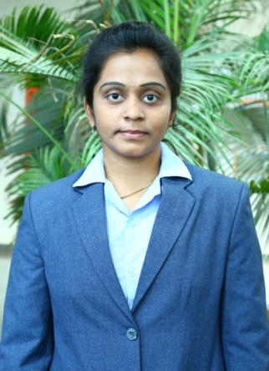

Ms. Valluri Venkata Rupa Sri Swetha
Graduated from Annamalai University, Chidambaram, Tamil Nadu.
Post-Graduation from Food and Agri Business School, Hyderabad, Telangana

Got Placed in

HDFC Bank Limited
as a Credit Manager

